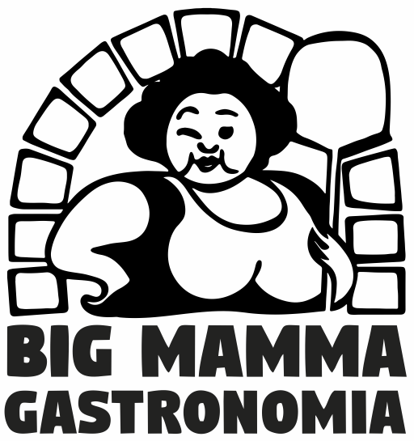

Big Mamma is a small pizzeria located in the center of Hillerød. The owners are extremely dedicated to baking Italian pizzas at the very highest level. They use fresh Italian ingredients to make the pizzas in a wood-fired stone oven. Although the Big Mamma Gastronomia name is new, the experience behind it is not. Big Mamma is a family owned business, started by the father Luca Ambrosini who created the pizzeria Costa Smeralda, which has been located in Gentofte for 30 years. 9 years ago Luca started Big Mamma and in 2020 he sold the pizzeria to his two sons, Giovanni and Mauro.

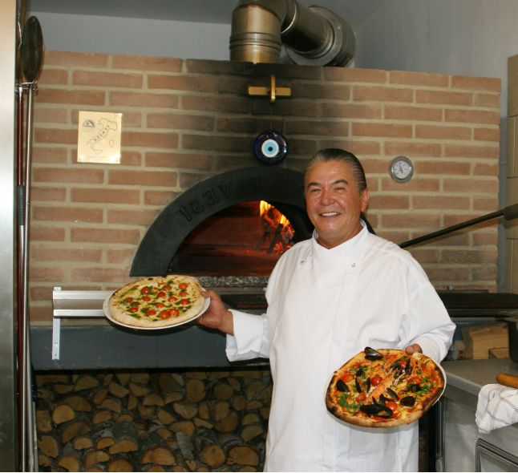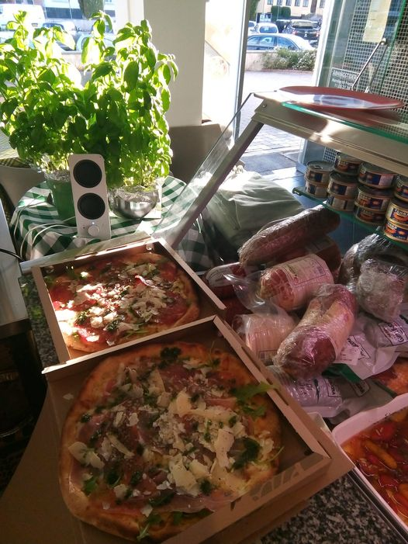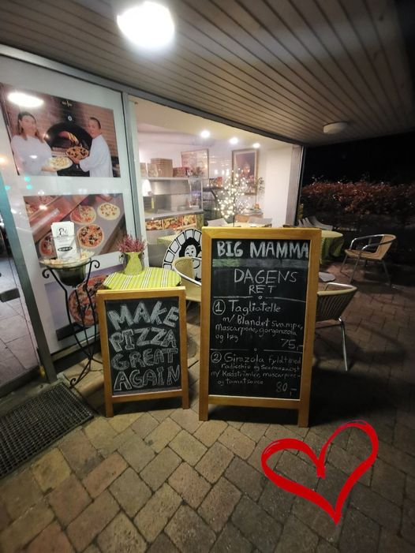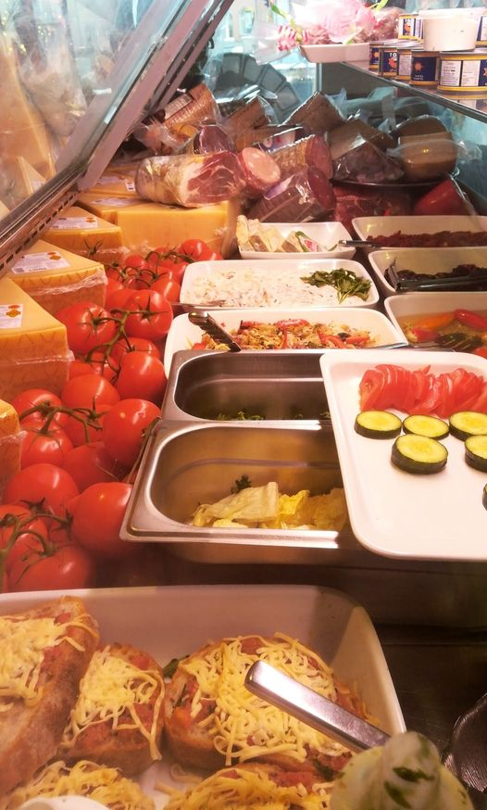

*Luca*

Big Mamma serves the customers in two ways: either take-away or you can sit in the pizzeria and eat. It is not possible to reserve a table. The pizzeria is not using **Just eat** or **Hungry** because the delivery companies it is too expensive to use and take too much profit. Each pizza order is worth an average of 100 kr per customer when you include drinks and extra topping. The direct cost of each sale is about 50 kr, leaving 50 kr in for fixed expenses and profit.

The sons have big dreams expanding the pizzeria and increasing sales. They plan to start a pizzeria in Roskilde in the near future.

At the moment the pizzeria don't have an order system. In the future the two sons want a new order system that can be used in the pizzeria and for online customers.

You are hired to help Big Mamma with designing and developing the new it system. In the first version you are going to focus on ordering a pizza with toppings.

Some of Big Mamma's wishes for the system is presenting their Pizzas in a menu, where it is possible to see toppings/ingredients and prices. The system should be used by the customers, management, pizza bakers and sales staff. It should be possible in the future to deliver pizza to the customer.

Giovanni and Mauro also want to have a customer club with discounts.

|  |
| --- |

*Part of the menu. The full menu can be found here big-mamma.dk/menu/ ( use google translate for an english version).*

Big Mamma has provided material(receipts and notes from ordering) to be used for the analysis.

|  |
| --- |

*Receipts*

|  |
| --- |

*To the left: Notes from a pizza order that is handled to the pizza baker. 1 pizza no 25, 1 pizza no 30 with extra cheese and 2 pizzas no 75. Customer name: Morten.*

*To the right: The proud creator of the Pizzaria*

Big Mamma wants a prototype on part of the new system. That is your job!